Given an array of integers preorder, which represents the **preorder traversal** of a BST (i.e., **binary search tree**), construct the tree and return *its root*.

It is **guaranteed** that there is always possible to find a binary search tree with the given requirements for the given test cases.

A **binary search tree** is a binary tree where for every node, any descendant of Node.left has a value **strictly less than** Node.val, and any descendant of Node.right has a value **strictly greater than** Node.val.

A **preorder traversal** of a binary tree displays the value of the node first, then traverses Node.left, then traverses Node.right.

**Example 1:**

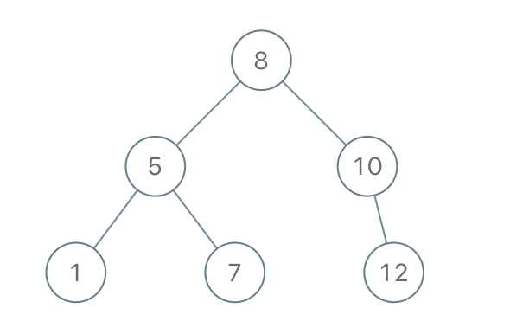

Input: preorder = [8,5,1,7,10,12]  
Output: [8,5,10,1,7,null,12]

**Example 2:**

Input: preorder = [1,3]  
Output: [1,null,3]

**Constraints:**

* 1 <= preorder.length <= 100
* 1 <= preorder[i] <= 1000
* All the values of preorder are **unique**.